STAT 448 Final Project

Analysis of IMDB-Rated Films

Minji Song Group 5

Introduction

In this project, I and my group member used IMDB dataset which is from Kaggle website. This dataset includes 4,917 unique films that have been rated by IMDB users. The dataset includes 26 variables, excluding the variables for the movie title and the IMDB website link. There are 14 continuous variables describing film-specific attributes such as budget, gross revenue, duration, IMDB score, number of IMDB reviewers, number of critic reviewers, number of faces in the movie poster, and six different variables for the number of Facebook likes. These six variables include the number of likes that the movie has, the main three actors/actresses, the director, and the total of the entire cast. There are also 13 categorical variables including the year the film was released, its aspect ratio, color, language, country of release, content rating, the names of the main three actors/actresses and the director, plot keywords, and genre keywords.

My goal of this project is to determine if there is any relationship between the IMDB score and all other categorical predictors such as color, director name and languages through Generalized Linear Regression Analysis. I converted categorical variable, director name, to three Tiers based on the number of movies they produce. The directors in Tier 1 produced more than 6 movies and the director in Tier 3 produced only 1 movie. In the middle of the Tier 1 and Tier 3, the director who produce more than one movie but less than six movies are in Tier 2. Also, there is a lot of options for language in this dataset. Seven languages were kept out of 57 different languages based on the number of languages used in movies in dataset. French, German, Hindi, Mandarin, Spanish and English are the unique language and I set the rest of the languages as Others. Through Generalized Linear Regression, I tried Gamma distribution and Poisson distribution in Regression. I compared parameter estimates, its p-value, Type 1 and Type 3 analysis, and diagnostics plot between two in order to choose a final model with the distribution. According to the analysis, I was able to interpret how each variable is significant to IMDB scores and which one is not significant.
Obs | imdb_score | color | director_name | language | num_dir
1 | 7.8 | Color | Tier 1 | English | 26
2 | 7.6 | Color | Tier 1 | English | 26
3 | 8.0 | Color | Tier 1 | English | 26
4 | 6.7 | Color | Tier 1 | English | 26
5 | 8.3 | Color | Tier 1 | English | 26
6 | 7.7 | Color | Tier 1 | English | 26
7 | 6.5 | Color | Tier 1 | English | 26
8 | 7.9 | Color | Tier 1 | English | 26
9 | 7.2 | Black an | Tier 1 | English | 26
10 | 8.1 | Color | Tier 1 | English | 26
11 | 7.6 | Color | Tier 1 | English | 26
12 | 8.5 | Color | Tier 1 | English | 26
13 | 7.3 | Color | Tier 1 | English | 26
14 | 7.4 | Color | Tier 1 | English | 26
15 | 8.9 | Black an | Tier 1 | English | 26

Obs | imdb_score | color | director_name | language | num_dir | newlanguage
1 | 7.8 | Color | Tier 1 | English | 26 | English
2 | 7.6 | Color | Tier 1 | English | 26 | English
3 | 8.0 | Color | Tier 1 | English | 26 | English
4 | 6.7 | Color | Tier 1 | English | 26 | English
5 | 8.3 | Color | Tier 1 | English | 26 | English
6 | 7.7 | Color | Tier 1 | English | 26 | English
7 | 6.5 | Color | Tier 1 | English | 26 | English
8 | 7.9 | Color | Tier 1 | English | 26 | English
9 | 7.2 | Black an | Tier 1 | English | 26 | English
10 | 8.1 | Color | Tier 1 | English | 26 | English
11 | 7.6 | Color | Tier 1 | English | 26 | English
12 | 8.5 | Color | Tier 1 | English | 26 | English
13 | 7.3 | Color | Tier 1 | English | 26 | English
14 | 7.4 | Color | Tier 1 | English | 26 | English
15 | 8.9 | Black an | Tier 1 | English | 26 | English
I defined director name into three different levels: Tier 1, Tier2 and Tier 3 based on the number of movies they produced.
About top 30 percent of directors produced more than 6 movies and they are defined as Tier 1. Lower 30 percent of directors produced 1 movie and they are defined as Tier 3. In the middle of producing movies between 1 movie and 6 movies, they in Tier 2.
Since there are so many unique languages, I defined unique 6 major languages and defined rest of them as others.
These tables show first 15 observations of the datasets after I convert the categorical variables.

Model Information
Data Set | WORK.IMDB
Distribution | Poisson
Link Function | Log
Dependent Variable | imdb_score

Criteria For Assessing Goodness Of Fit
Criterion | DF | Value | Value/DF
Deviance | 4912 | 925.1841 | 0.1884
Scaled Deviance | 4912 | 4912.0000 | 1.0000
Pearson Chi-Square | 4912 | 868.5429 | 0.1768
Scaled Pearson X2 | 4912 | 4611.2795 | 0.9388
Log Likelihood |  | 144466.5420
Full Log Likelihood |  | -9584.5236
AIC (smaller is better) |  | 19189.0471
AICC (smaller is better) |  | 19189.0919
BIC (smaller is better) |  | 19254.0618

Analysis Of Maximum Likelihood Parameter Estimates
Parameter |  | DF | Estimate | Standard  Error | Wald 95% Confidence Limits |  | Wald Chi-Square | Pr > ChiSq
Intercept |  | 1 | 2.0135 | 0.0120 | 1.9901 | 2.0370 | 28259.0 | <.0001
color | Color | 1 | -0.1147 | 0.0116 | -0.1374 | -0.0920 | 97.99 | <.0001
color | Black an | 0 | 0.0000 | 0.0000 | 0.0000 | 0.0000 | . | .
director_name | Tier 2 | 1 | -0.0452 | 0.0060 | -0.0569 | -0.0335 | 57.16 | <.0001
director_name | Tier 3 | 1 | -0.1118 | 0.0066 | -0.1249 | -0.0988 | 282.95 | <.0001
director_name | Tier 1 | 0 | 0.0000 | 0.0000 | 0.0000 | 0.0000 | . | .
newlanguage | French | 1 | 0.1292 | 0.0196 | 0.0909 | 0.1676 | 43.59 | <.0001
newlanguage | German | 1 | 0.1407 | 0.0370 | 0.0682 | 0.2132 | 14.48 | 0.0001
newlanguage | Hindi | 1 | 0.0811 | 0.0320 | 0.0183 | 0.1440 | 6.41 | 0.0113
newlanguage | Mandarin | 1 | 0.0472 | 0.0335 | -0.0184 | 0.1128 | 1.99 | 0.1584
newlanguage | Other | 1 | 0.1383 | 0.0141 | 0.1107 | 0.1659 | 96.54 | <.0001
newlanguage | Spanish | 1 | 0.1179 | 0.0262 | 0.0665 | 0.1693 | 20.19 | <.0001
newlanguage | English | 0 | 0.0000 | 0.0000 | 0.0000 | 0.0000 | . | .
Scale |  | 0 | 0.4340 | 0.0000 | 0.4340 | 0.4340

Note: | The scale parameter was estimated by the square root of DEVIANCE/DOF.

LR Statistics For Type 1 Analysis
Source | Deviance | Num DF | Den DF | F Value | Pr > F | Chi-Square | Pr > ChiSq
Intercept | 1018.7255
color | 998.2865 | 1 | 4912 | 108.52 | <.0001 | 108.52 | <.0001
director_name | 956.1833 | 2 | 4912 | 111.77 | <.0001 | 223.53 | <.0001
newlanguage | 925.1841 | 6 | 4912 | 27.43 | <.0001 | 164.58 | <.0001

LR Statistics For Type 3 Analysis
Source | Num DF | Den DF | F Value | Pr > F | Chi-Square | Pr > ChiSq
color | 1 | 4912 | 94.73 | <.0001 | 94.73 | <.0001
director_name | 2 | 4912 | 144.95 | <.0001 | 289.90 | <.0001
newlanguage | 6 | 4912 | 27.43 | <.0001 | 164.58 | <.0001
After estimating the scale, we can see that all of director name, color and some of newlanguage in parameter estimates table have lower p values than 0.05 which means it is significant. The baseline of this model is the first variable because it is the predominant variable in this model. Color is significantly different from black and white. For director name, Tier 2 and Tier 3 are significantly different from Tier 1. In newlanguage, French, Spanish, Hindi, German, and other languages are significantly different from English. Mandarin is insignificant.
Type 1 analysis indicates that all predictors are significant. Type 3 analysis has the same result as Type 1, it indicates that all predictors are significant. We are pretty sure that we keep the color variable, but we need to see if we keep other variables as well.

Analysis Of Maximum Likelihood Parameter Estimates
Parameter |  | DF | Estimate | Standard  Error | Wald 95% Confidence Limits |  | Wald Chi-Square | Pr > ChiSq
Intercept |  | 1 | 2.0135 | 0.0120 | 1.9901 | 2.0370 | 28259.0 | <.0001
color | Color | 1 | -0.1147 | 0.0116 | -0.1374 | -0.0920 | 97.99 | <.0001
color | Black an | 0 | 0.0000 | 0.0000 | 0.0000 | 0.0000 | . | .
director_name | Tier 2 | 1 | -0.0452 | 0.0060 | -0.0569 | -0.0335 | 57.16 | <.0001
director_name | Tier 3 | 1 | -0.1118 | 0.0066 | -0.1249 | -0.0988 | 282.95 | <.0001
director_name | Tier 1 | 0 | 0.0000 | 0.0000 | 0.0000 | 0.0000 | . | .
newlanguage | French | 1 | 0.1292 | 0.0196 | 0.0909 | 0.1676 | 43.59 | <.0001
newlanguage | German | 1 | 0.1407 | 0.0370 | 0.0682 | 0.2132 | 14.48 | 0.0001
newlanguage | Hindi | 1 | 0.0811 | 0.0320 | 0.0183 | 0.1440 | 6.41 | 0.0113
newlanguage | Mandarin | 1 | 0.0472 | 0.0335 | -0.0184 | 0.1128 | 1.99 | 0.1584
newlanguage | Other | 1 | 0.1383 | 0.0141 | 0.1107 | 0.1659 | 96.54 | <.0001
newlanguage | Spanish | 1 | 0.1179 | 0.0262 | 0.0665 | 0.1693 | 20.19 | <.0001
newlanguage | English | 0 | 0.0000 | 0.0000 | 0.0000 | 0.0000 | . | .
Scale |  | 0 | 0.4340 | 0.0000 | 0.4340 | 0.4340

Note: | The scale parameter was estimated by the square root of DEVIANCE/DOF.
The parameter estimate of color is -0.1147 indicating an increase of one in color, imdb_score is expected to be increasing by e^-0.1147.and the parameter estimate of tier 2 is -0.0452 indicating an increase of one in tier2, imdb_score is expected to be increasing by e^-0.0452.and the parameter estimate of tier 3 is -0.1118 indicating an increase of one in tier3, imdb_score is expected to be increasing by e^-0.1118.the parameter estimate of French in newlanguage is 0.1292 indicating an increase of one in French, imdb_score is expected to be increasing by e^0.1292.the parameter estimate of Spanish in newlanguage is 0.1179 indicating an increase of one in Spanish, imdb_score is expected to be increasing by e^0.1179.the parameter estimate of German in newlanguage is 0.1407 indicating an increase of one in German, imdb_score is expected to be increasing by e^0.0.1407.the parameter estimate of Hindi in newlanguage is 0.0811 indicating an increase of one in Hindi, imdb_score is expected to be increasing by e^0.0811.the parameter estimate of other in newlanguage is 0.1383 indicating an increase of one in other, imdb_score is expected to be increasing by e^0.1383..

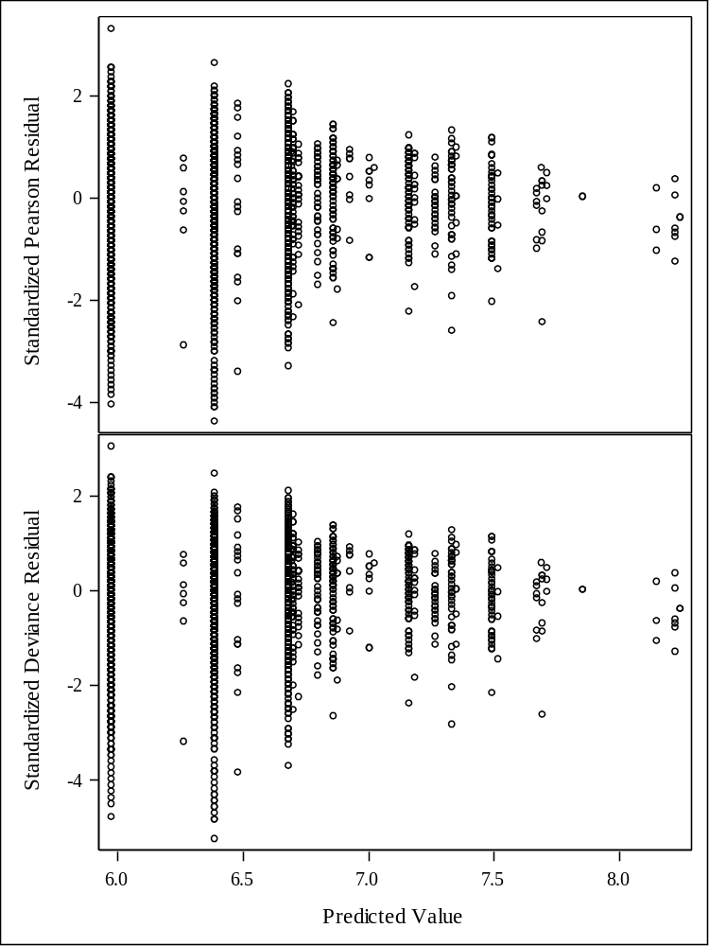
The scatter plot indicates that the residuals is narrowing as the predicted value increases. It is because first two predicted values have much more observations than last few values. I assumes this is why it has narrow trend.

Model Information
Data Set | WORK.IMDB
Distribution | Poisson
Link Function | Log
Dependent Variable | imdb_score

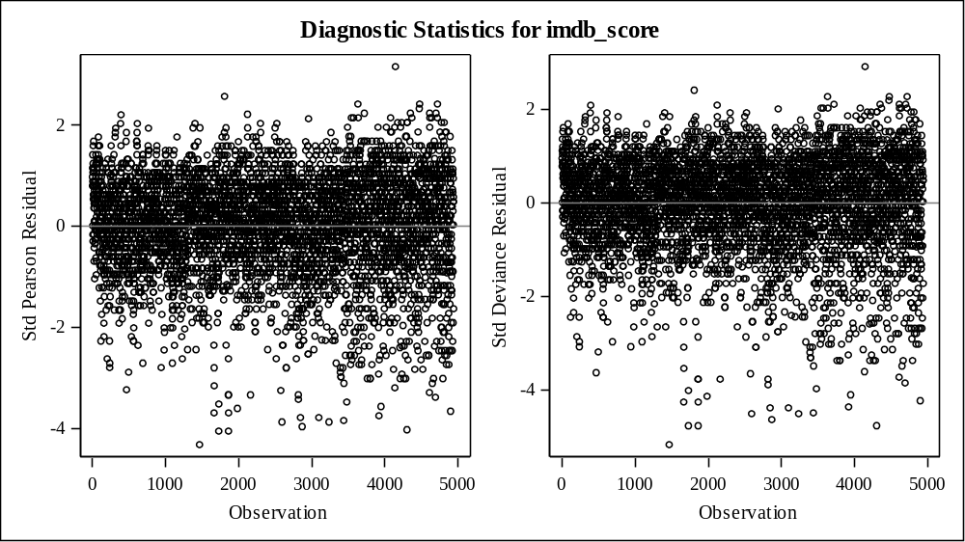
As we look at the diagnostic plot, the residuals are flat enough, so the model is fine.

Model Information
Data Set | WORK.IMDB
Distribution | Gamma
Link Function | Log
Dependent Variable | imdb_score

Criteria For Assessing Goodness Of Fit
Criterion | DF | Value | Value/DF
Deviance | 4912 | 160.8283 | 0.0327
Scaled Deviance | 4912 | 4912.0000 | 1.0000
Pearson Chi-Square | 4912 | 137.5110 | 0.0280
Scaled Pearson X2 | 4912 | 4199.8451 | 0.8550
Log Likelihood |  | -7643.0117
Full Log Likelihood |  | -7643.0117
AIC (smaller is better) |  | 15306.0234
AICC (smaller is better) |  | 15306.0682
BIC (smaller is better) |  | 15371.0381

Analysis Of Maximum Likelihood Parameter Estimates
Parameter |  | DF | Estimate | Standard  Error | Wald 95% Confidence Limits |  | Wald Chi-Square | Pr > ChiSq
Intercept |  | 1 | 2.0149 | 0.0134 | 1.9887 | 2.0411 | 22703.4 | <.0001
color | Color | 1 | -0.1160 | 0.0129 | -0.1413 | -0.0906 | 80.44 | <.0001
color | Black an | 0 | 0.0000 | 0.0000 | 0.0000 | 0.0000 | . | .
director_name | Tier 2 | 1 | -0.0453 | 0.0064 | -0.0579 | -0.0328 | 50.08 | <.0001
director_name | Tier 3 | 1 | -0.1122 | 0.0070 | -0.1259 | -0.0985 | 256.20 | <.0001
director_name | Tier 1 | 0 | 0.0000 | 0.0000 | 0.0000 | 0.0000 | . | .
newlanguage | French | 1 | 0.1303 | 0.0216 | 0.0880 | 0.1726 | 36.41 | <.0001
newlanguage | German | 1 | 0.1402 | 0.0417 | 0.0584 | 0.2220 | 11.28 | 0.0008
newlanguage | Hindi | 1 | 0.0808 | 0.0344 | 0.0134 | 0.1482 | 5.51 | 0.0189
newlanguage | Mandarin | 1 | 0.0458 | 0.0363 | -0.0254 | 0.1170 | 1.59 | 0.2071
newlanguage | Other | 1 | 0.1395 | 0.0156 | 0.1089 | 0.1701 | 79.81 | <.0001
newlanguage | Spanish | 1 | 0.1185 | 0.0288 | 0.0620 | 0.1749 | 16.92 | <.0001
newlanguage | English | 0 | 0.0000 | 0.0000 | 0.0000 | 0.0000 | . | .
Scale |  | 0 | 30.5419 | 0.0000 | 30.5419 | 30.5419

Note: | The Gamma scale parameter was estimated by DOF/DEVIANCE.

LR Statistics For Type 1 Analysis
Source | Deviance | Num DF | Den DF | F Value | Pr > F | Chi-Square | Pr > ChiSq
Intercept | 175.3121
color | 172.2449 | 1 | 4912 | 93.68 | <.0001 | 93.68 | <.0001
director_name | 165.6468 | 2 | 4912 | 100.76 | <.0001 | 201.52 | <.0001
newlanguage | 160.8283 | 6 | 4912 | 24.53 | <.0001 | 147.17 | <.0001

LR Statistics For Type 3 Analysis
Source | Num DF | Den DF | F Value | Pr > F | Chi-Square | Pr > ChiSq
color | 1 | 4912 | 83.32 | <.0001 | 83.32 | <.0001
director_name | 2 | 4912 | 131.38 | <.0001 | 262.75 | <.0001
newlanguage | 6 | 4912 | 24.53 | <.0001 | 147.17 | <.0001
This time, I tried gamma distribution and the result is really similar to poisson distribution. After estimating the scale, we can see that all of director name, color and some of newlanguage are significant. The baseline of this model is the first variable because it is the predominant variable in this model. Color is significantly different from black and white. For director name, Tier 2 and Tier 3 are significantly different from Tier 1.In newlanguage, French, Spanish, Hindi, German, and other languages are significantly different from English. Only Mandarin is insignificant.
Type 1 analysis indicates that all predictors are significant.Type 3 analysis has the same result as Type 1, it indicates that all predictors are significant.

Analysis Of Maximum Likelihood Parameter Estimates
Parameter |  | DF | Estimate | Standard  Error | Wald 95% Confidence Limits |  | Wald Chi-Square | Pr > ChiSq
Intercept |  | 1 | 2.0149 | 0.0134 | 1.9887 | 2.0411 | 22703.4 | <.0001
color | Color | 1 | -0.1160 | 0.0129 | -0.1413 | -0.0906 | 80.44 | <.0001
color | Black an | 0 | 0.0000 | 0.0000 | 0.0000 | 0.0000 | . | .
director_name | Tier 2 | 1 | -0.0453 | 0.0064 | -0.0579 | -0.0328 | 50.08 | <.0001
director_name | Tier 3 | 1 | -0.1122 | 0.0070 | -0.1259 | -0.0985 | 256.20 | <.0001
director_name | Tier 1 | 0 | 0.0000 | 0.0000 | 0.0000 | 0.0000 | . | .
newlanguage | French | 1 | 0.1303 | 0.0216 | 0.0880 | 0.1726 | 36.41 | <.0001
newlanguage | German | 1 | 0.1402 | 0.0417 | 0.0584 | 0.2220 | 11.28 | 0.0008
newlanguage | Hindi | 1 | 0.0808 | 0.0344 | 0.0134 | 0.1482 | 5.51 | 0.0189
newlanguage | Mandarin | 1 | 0.0458 | 0.0363 | -0.0254 | 0.1170 | 1.59 | 0.2071
newlanguage | Other | 1 | 0.1395 | 0.0156 | 0.1089 | 0.1701 | 79.81 | <.0001
newlanguage | Spanish | 1 | 0.1185 | 0.0288 | 0.0620 | 0.1749 | 16.92 | <.0001
newlanguage | English | 0 | 0.0000 | 0.0000 | 0.0000 | 0.0000 | . | .
Scale |  | 0 | 30.5419 | 0.0000 | 30.5419 | 30.5419

Note: | The Gamma scale parameter was estimated by DOF/DEVIANCE.
The parameter estimate of color is -0.1160 indicating an increase of one in color, imdb_score is expected to be increasing by e^-0.1160.and the parameter estimate of tier 2 is -0.0453 indicating an increase of one in tier2, imdb_score is expected to be increasing by e^-0.0453.and the parameter estimate of tier 3 is -0.1122 indicating an increase of one in tier3, imdb_score is expected to be increasing by -0.1122.
The parameter estimate of French in newlanguage is 0.1303 indicating an increase of one in French, imdb_score is expected to be increasing by e^0.1303.the parameter estimate of Spanish in newlanguage is 0.1185 indicating an increase of one in Spanish, imdb_score is expected to be increasing by e^0.1185.the parameter estimate of German in newlanguage is 0.1402 indicating an increase of one in German, imdb_score is expected to be increasing by e^0.0.1402.the parameter estimate of Hindi in newlanguage is 0.0808 indicating an increase of one in Hindi, imdb_score is expected to be increasing by e^0.0808.the parameter estimate of other in newlanguage is 0.1395 indicating an increase of one in other, imdb_score is expected to be increasing by e^0.1395..

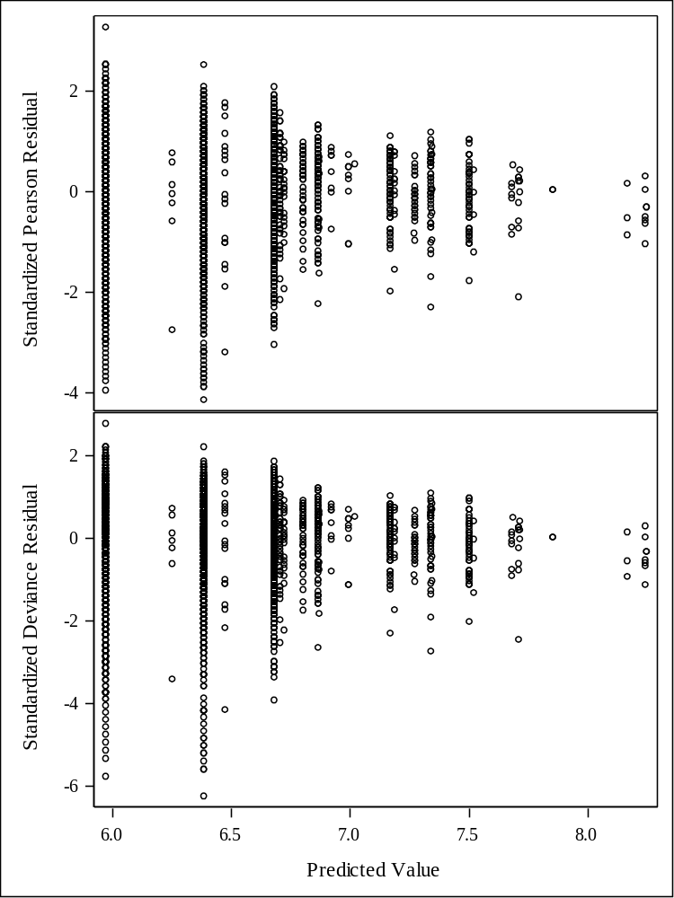
The scatter plot is also very similar to Poisson distribution. it indicates that the residuals are narrowing as the predicted value increases. It is because first two predicted values have much more observations than last few values. I assume this is why it has narrow trend.

Model Information
Data Set | WORK.IMDB
Distribution | Gamma
Link Function | Log
Dependent Variable | imdb_score

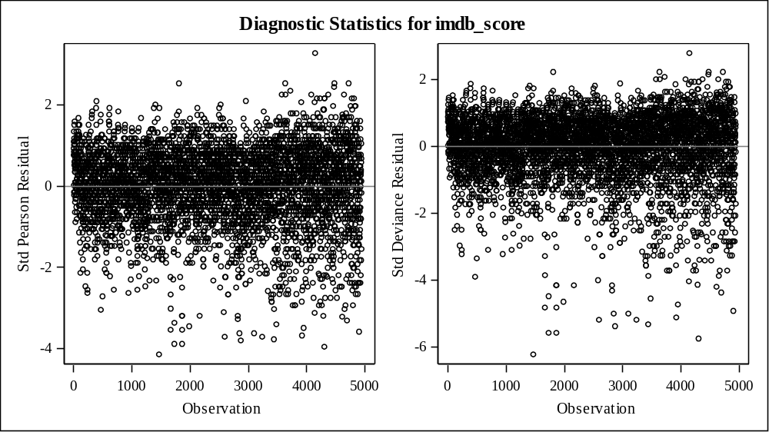
As we look at the diagnostic plot, the residuals are flat enough, so the model is fine.

Number of Observations Read | 4939
Number of Observations Used | 4922
Missing Values | 17

Class Level Information
Class | Levels | Values
color | 2 | Black an Color
director_name | 3 | Tier 1 Tier 2 Tier 3
newlanguage | 7 | English French German Hindi Mandarin Other Spanish

Algorithm converged.

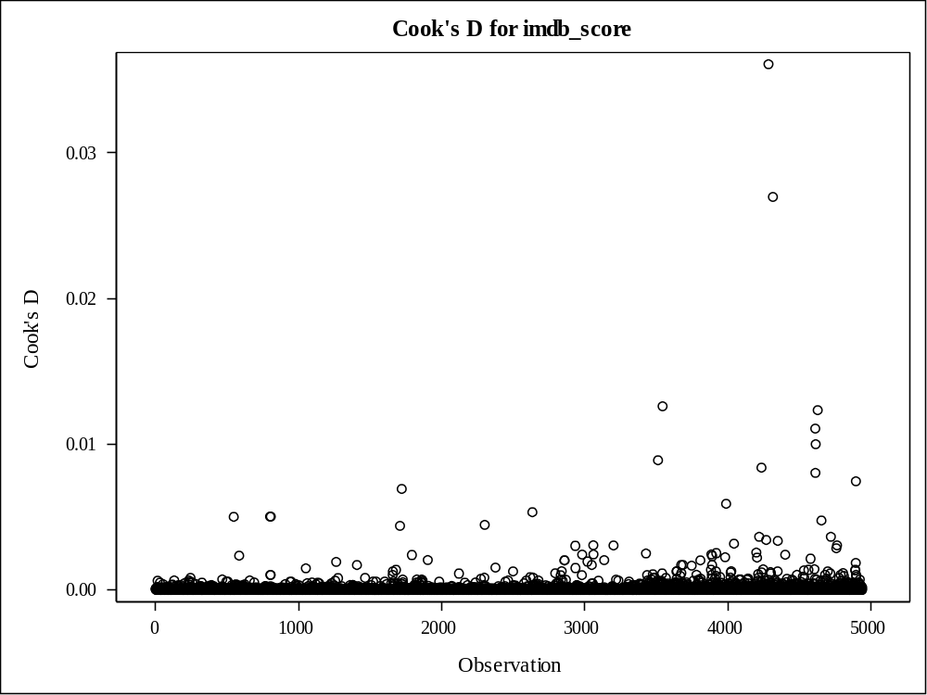

I chose to check if there are any influential points in model with gamma distribution. The reason I chose gamma distribution is because since I use continuous variable as response variable, gamma distribution is better than Poisson distribution which is appropriate for discrete variable. As I checked cooks’ distance, there are some high influential points compared to other points, but it is not big enough to remove in terms of rule of thumb. so, we can conclude there is no influential points this model and it is reasonable model to use.

Conclusion

Through the analysis, I found the relationship between IDMB scores and color, Director name, and language. Before I start to perform any regression, there are too many unique director names in data, I had to divide directors into three tiers based on the number of movies they produced. Also, there is about 50 different languages in movie data, so I had to sort it out to make the data simple. I kept six languages the most used in movie and defined the rest of them as others.

To find the relationship between the response and the predictor variables, I performed Generalized Linear Regression with Poisson distribution first. The parameter estimates indicate how much the independent variables influence the response. The baseline of this model is the first independent variable because the first variable is a majority variable in the dataset. Color movies are a significantly different from black and white movies with a negative value. This means that color movies influence IMDB scores, but it is a negative impact on the score and black and white movies have positive impact on the score. I think this is because the number of observations of color is much more than black and white movies, so black and white movies with less observations would have more influence than color. For the directors, Tier 2 and Tier 3 are significantly different from Tier 1 with negative values. Tier 1 will have positive impact on IMDB scores whereas Tier 2 and Tier 3 have negative impact on IMDB scores. There are six unique languages and other, the rest of the languages, in the data and all languages are significantly different from English except only one language, Mandarin. They all have positive values which means that foreign languages tend to have higher IMDB score. The reason that English movies have lower score on IMDB is because about 90% of the movies are in English. It has a lot of observations than foreign movies and it possibly tend to see that the score of English movies is lower than foreign movies. I also looked at the diagnostic results and diagnostic plot looked perfectly fine, However, the scatter plot indicates that the residuals is narrowing as the predicted value increases which means it is not a good sign for the model. I assumed it is because the there are a lot of observations in first two predicted values compared to last two predicted value. We can see that there are many non-overlapped data in the first two predicted values and these non-overlapped points can be explained as extra observations, so I think this is okay.

I also performed Generalized Linear Regression with Gamma distribution and the result is very similar to Poisson distribution. The significant variables are color, director name and language except Mandarin. The sign of the parameter estimate is also the same as Poisson distribution model. For the final model, I chose gamma distribution because the response is a continuous variable and Gamma distribution is appropriate for this rather than Poisson distribution which is appropriate for discrete response variable. With the final model, I conducted cook’s distance check to see if there are any influential points in data, and if so, I would remove the points from the data. There are no influential points in Gamma distribution. Thus, this model seems reasonable and useful to interpret.

